**Session 1**

1 Print Hello World

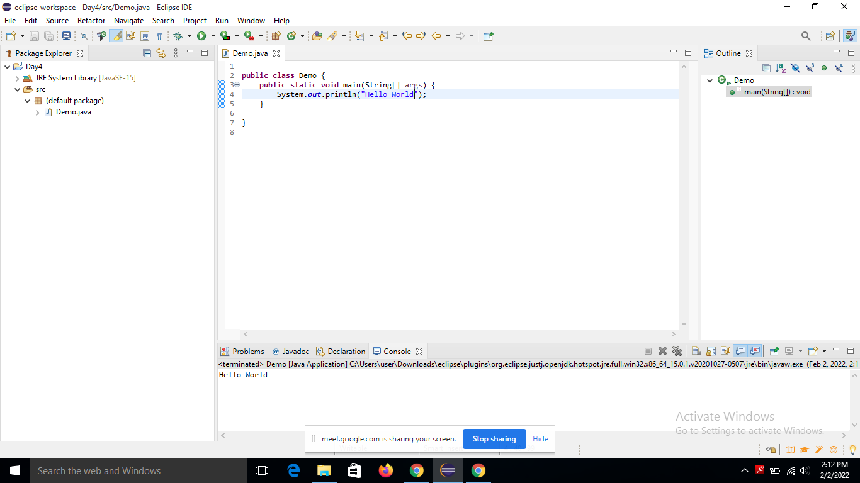

2 Add two numbers/binary numbers/characters

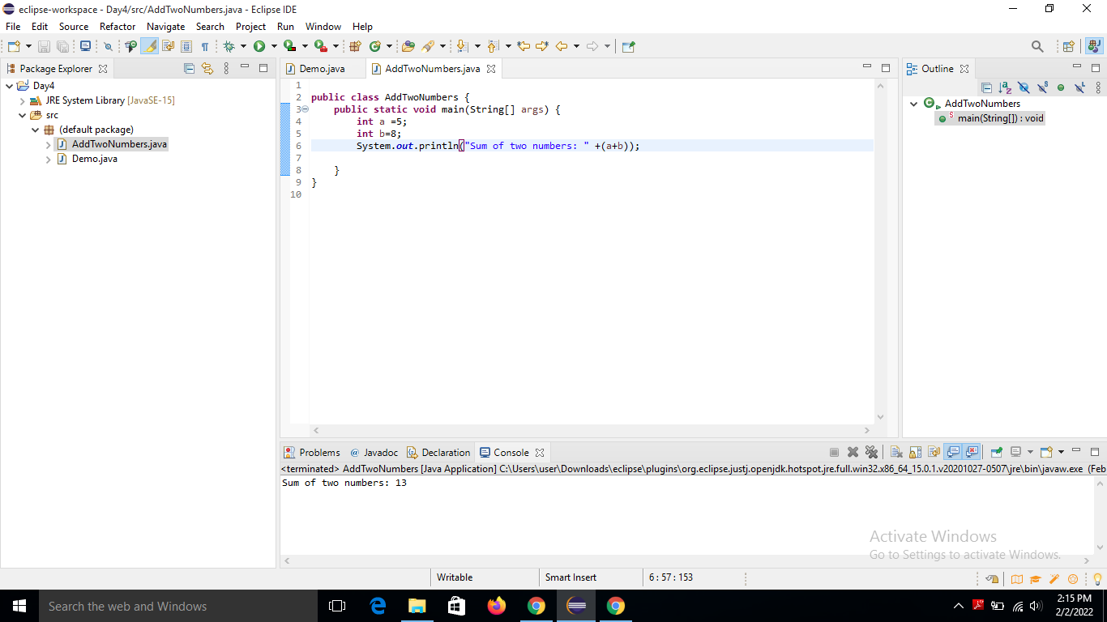

3 (i) Calculate Compound interest

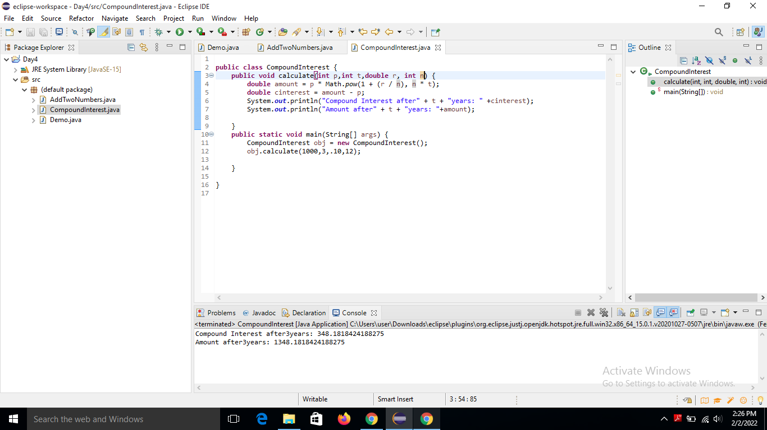

(ii) Swap two numbers

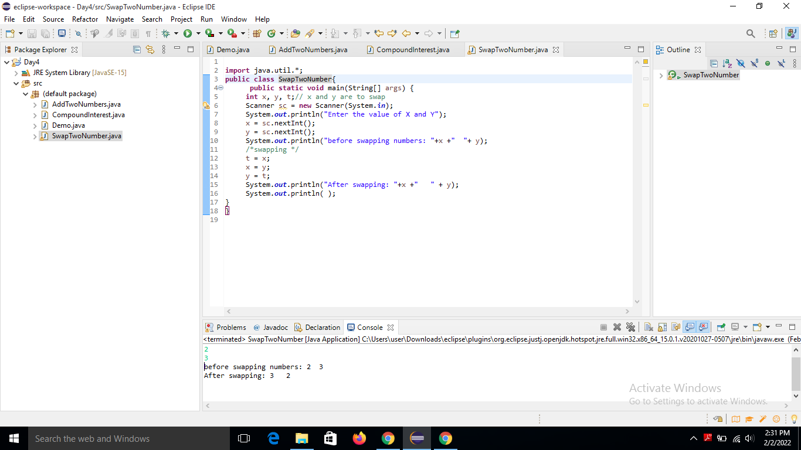

4 Calculate the area of rectangle Calculate area and circumference of a circle using multiple classes

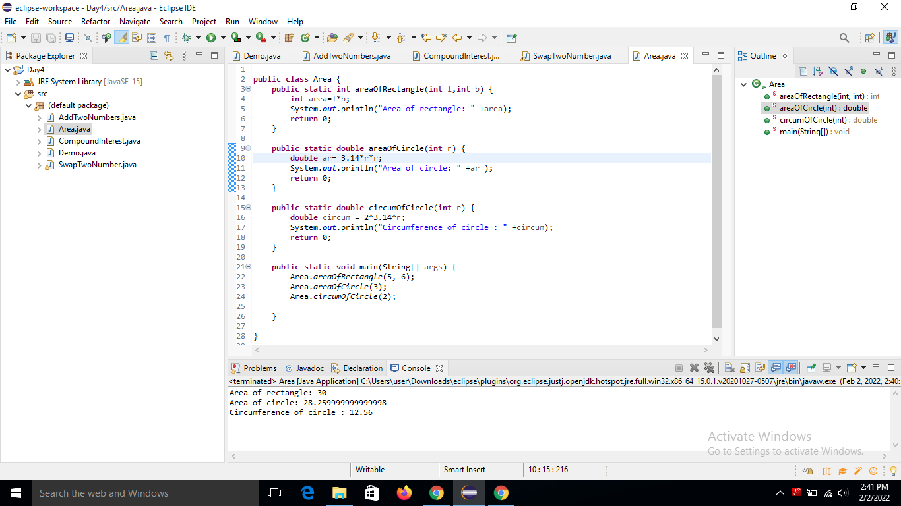

5 Print default values of a primitive data type variable

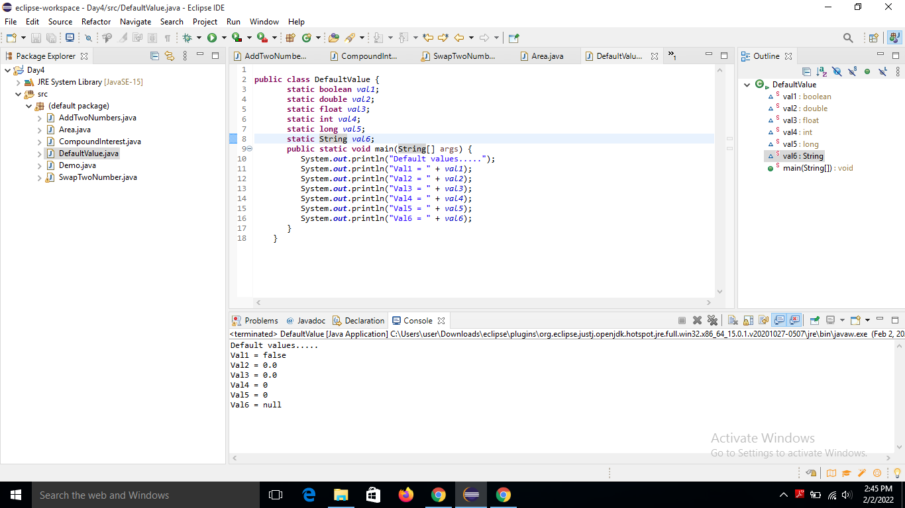

6 Print Fibonacci series till n

